Jayden Wilson (Student)
User Guide
Airline - Distinct

Contents
Introduction 1
Launching the Application 1
Navigating the Main Menu 6
Managing Customers 6
Managing Flights 7
Managing Bookings 8
Managing Routes 9
Exporting Data 10

Introduction
Airline Distinct is a streamlined terminal-based management system designed for efficient data entry and organization. This application provides a centralized interface to manage Flights, Bookings, Customers, and Routes, featuring a robust export tool that generates categorized CSV files for external reporting and data analysis.
Please note that green text means data that you can input for corresponding fields

Launching the Application
To effectively use this application please follow the instructions below:
- Go to a storage location on your device you wish to store the application in this guide that will be C:\
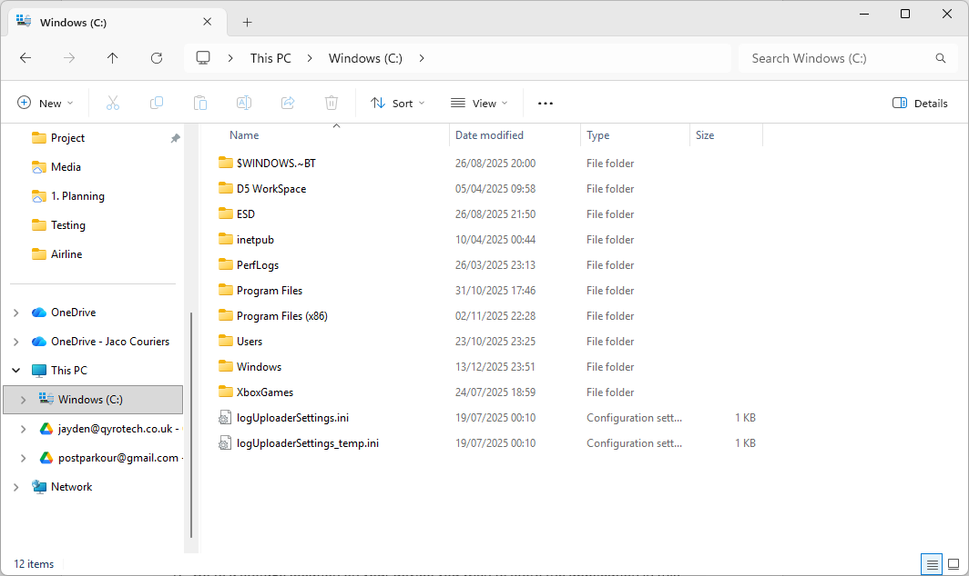

- Now that you have done that type CMD in the top search bar
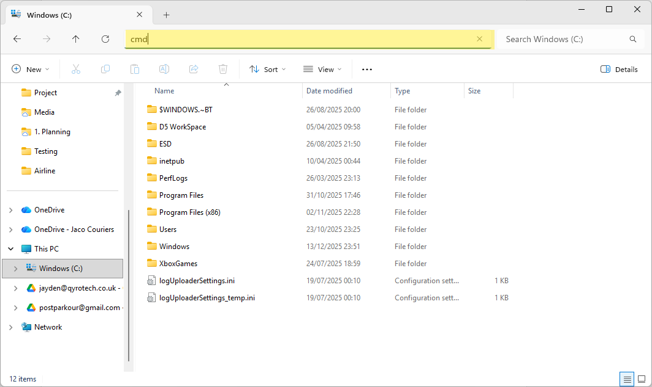
- You will now see a terminal window. Type the following
git clone https://github.com/Jayden-Wilson-01/Airline.git
You will then see a few messages this is to tell you that the files are being downloaded correctly. If you do not have git install it here.
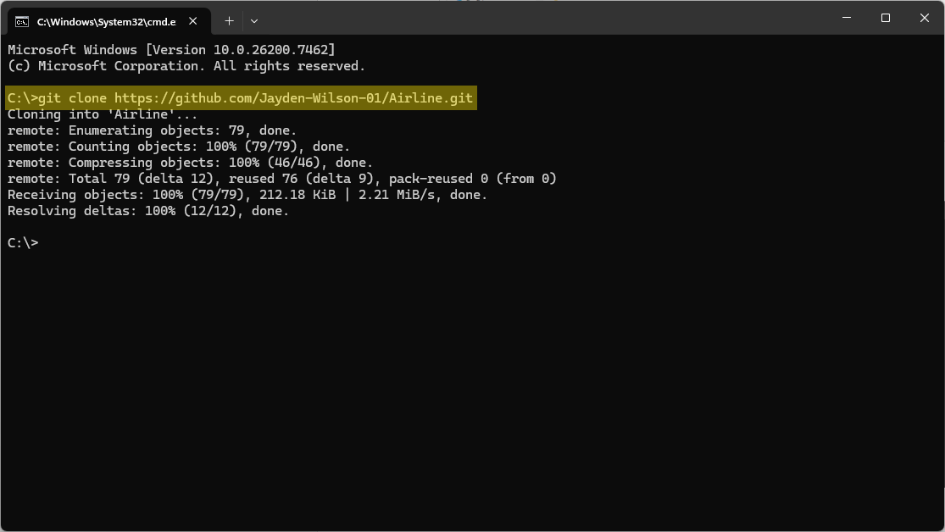

- If you go back to your folder in this case C:\ you will see a folder called Airline
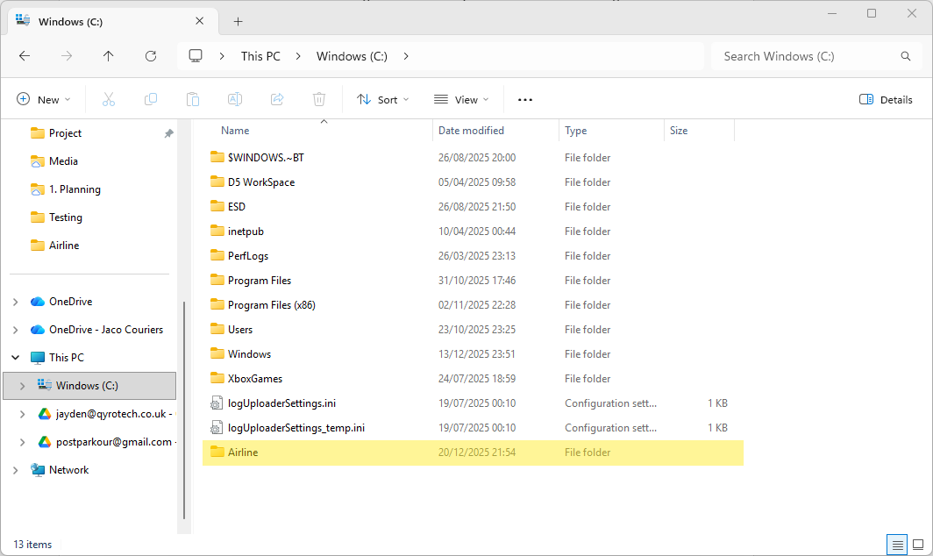
- Now open IntelliJ, click on open folder then use Airline.
If you do not have IntelliJ download it here
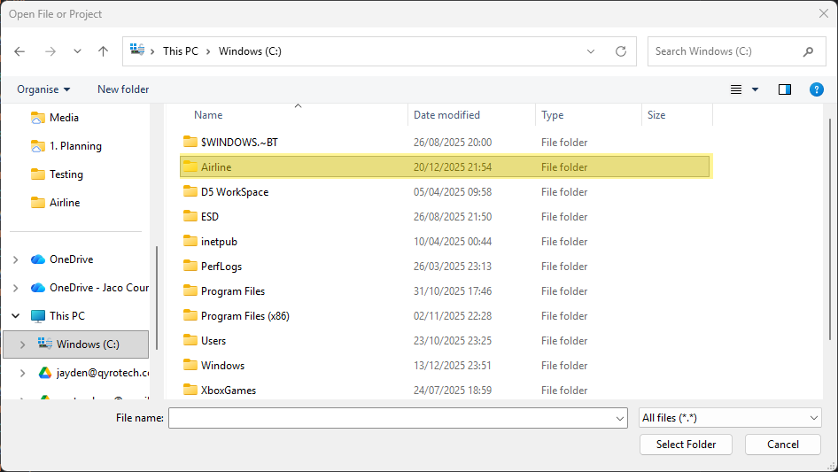

- Now you will see IntelliJ with the project opened. Navigate to main.js and then click run
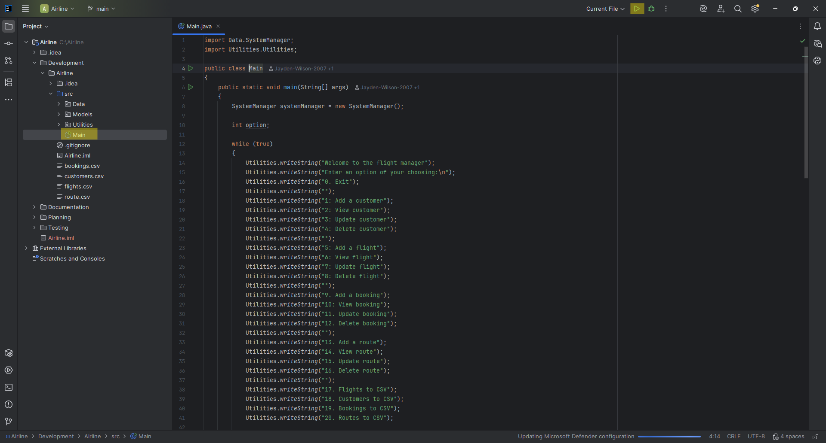
- Now you will see a list of options. You have successfully launched the app.
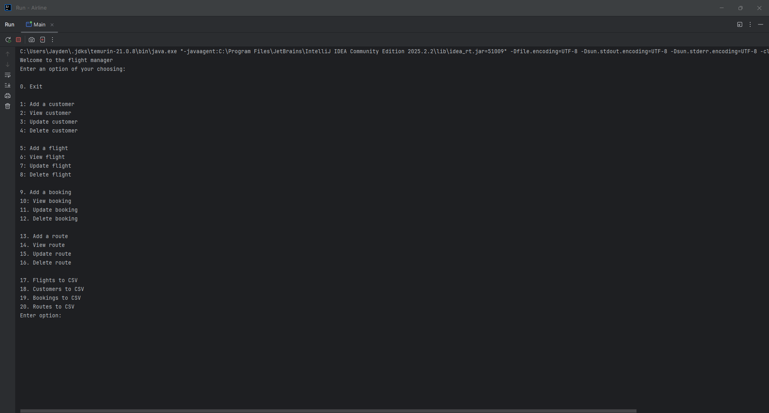

Navigating the Main Menu
The application uses a numeric selection system. To perform an action: Type the number corresponding to your desired task, then press Enter to confirm.
Category | Add | View | Update | Delete | Export to CSV
Customers | 1 | 2 | 3 | 4 | 18
Flights | 5 | 6 | 7 | 8 | 17
Bookings | 9 | 10 | 11 | 12 | 19
Routes | 13 | 14 | 15 | 16 | 20

Managing Customers
- To add a customer type 1 then enter data for the fields, below is an example:
CustomerID is case sensitive
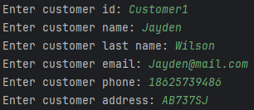
- To view a customer type 2 Then enter a customerID, below is an example:
CustomerID is case sensitive. CustomerID must exist.
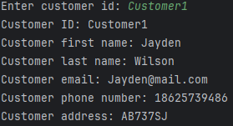

- To update a customer type 3 then enter an existing customerID then enter data for the fields, below is an example: CustomerID is case sensitive. CustomerID must exist.
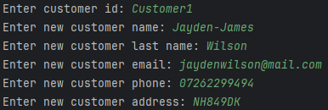
- To delete a customer type 4 then enter an existing customerID, below is an example: CustomerID is case sensitive. CustomerID must exist.

Managing Flights
- To add a flight type 5 then enter data for the fields, below is an example:
FlightID is case sensitive. Arrival date can only be the same or after departure date.
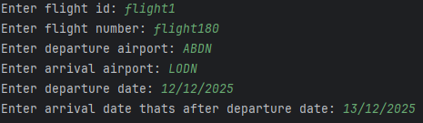
- To view a flight type 6 Then enter a flightID, below is an example:
FlightID is case sensitive. FlightID must exist.
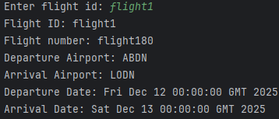

- To update a flight type 7 then enter an existing flightID then enter data for the fields, below is an example: FlightID is case sensitive. Arrival date can only be the same or after departure date. FlightID must exist.
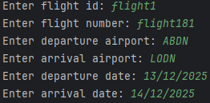
- To delete a flight type 8 then enter an existing flightID, below is an example: FlightID is case sensitive. FlightID must exist.

Managing Bookings
- To add a booking type 9 then enter data for the fields, below is an example:
BookingID, CustomerID, FlightID are case sensitive. CustomerID and FlightID must be exist.
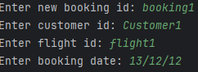
- To view a booking type 10 Then enter a bookingID, below is an example:
BookingID is case sensitive. BookingID must exist.
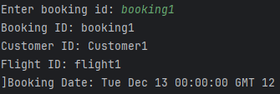

- To update a booking type 11 then enter an existing bookingID then enter data for the fields, below is an example: BookingID, CustomerID, FlightID are case sensitive. BookingID, CustomerID and FlightID must be exist.
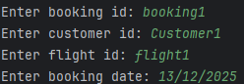
- To delete a booking type 12 then enter an existing bookingID, below is an example: BookingID is case sensitive

Managing Routes
- To add a route type 13 then enter data for the fields, below is an example:
RouteID is case sensitive.
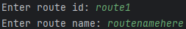
- To view a route type 14 Then enter a routeID, below is an example:
RouteID is case sensitive. RouteID must exist.
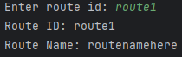
- To update a route type 15 then enter an existing routeID then enter data for the fields, below is an example:
RouteID is case sensitive. RouteID must exist.
- To delete a route type 16 then enter an existing routeID, below is an example: RouteID is case sensitive. RouteID must exist.

Exporting Data
- To export customers, type 18. You will then find the CSV file in this case in C:\Airline
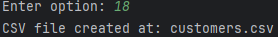
- To export flights, type 17. You will then find the CSV file in this case in C:\Airline
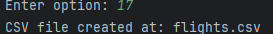
- To export bookings, type 19. You will then find the CSV file in this case in C:\Airline
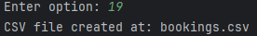
- To export routes, type 20. You will then find the CSV file in this case in C:\Airline
